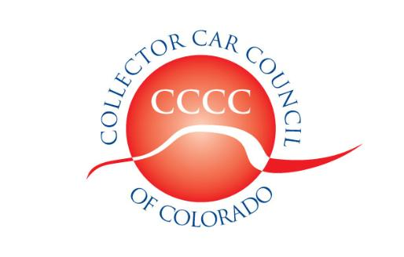

Dedicated to the preservation of automotive history

www.collectorcarcouncil.com

President: Dick Thompson, Denver Mustang Club 303-929-5533 Thompson660@cs.com
1st Vice Pres: John Ehrlich, ColoRODans 303-526-6805 Altechprec@yahoo.com
2nd Vice Pres: Calvin Craig, Colorado MOPAR Club 303-668-5142 CalvinCraig@msn.com
Secretary: Dick Fritz, MG Car Club 720-438-0191 RBFritz7@gmail.com
Treasurer: Tom Mansfield, Looking Glass Corvette 303-901-3562 tommans@outlook.com
Legislative information: Leo J. Boyle 303-321-6611 Leojboyle@aol.com
Political Committee Liaison: Dick Thompson 303-929-5533 Thompson660@cs.com
Web site liaison: Ben Aycrigg, RMR AACA 303-359-1350 Baycrigg@Live.com
RMMA Car Show & Swap Meet: Rick Ruel, Cobra Club 303-919-3760 rickrule@comcast.net
SEMA Show coordinator: John Ehrlich, ColoRODans 303-526-6805 Altechprec@yahoo.com
Forney DnS coordinator: Rick Beets, RM Corsa 303-475-5366 Rick@mylifeatspeed.com

Minutes of the 5 November 2025 Meeting
The meeting was held at the Forney Museum of Transportation 4303 Brighton Blvd., Denver, CO. 28 member-club representatives and one associate member were signed in. Officers present were Dick Thompson, President; John Ehrlich, 1st Vice President; Calvin Craig, 2nd Vice President; Richard Fritz, secretary; and Tom Mansfield, Treasurer. The meeting was called to order at 7:31 pm.
Guest Speaker: Nicole DiPace discussed the variety of health care insurance options available for seniors currently, starting first with Medicare Part A (hospital stays) and Part B (Doctors and Outpatient visits) and moving on to Medicare Supplements and Medicare Part C and Drug coverage (Part D). She is available for individual consultation at 720-909-8029.
Legislation: Leo Boyle noted that the off-year national elections are being studied to watch their effect on next year’s mid-term elections, including Medicaid costs which will influence Colorado’s budgets and Tabor rebates, if any. Meanwhile the Colorado Legislature will reconvene in January and be in session for 120 days. In 2025, HB25-1127 sought to provide a path for registering surplus military vehicles and passed in the transportation committee but was doomed in the appropriations committee by its fiscal note. Unfortunately, political affiliation is also a factor in success of proposed legislation.
The record (minutes) of the October 1st meeting was approved as published.
The Treasurer’s Report with a summary of accounts as of the end of October was presented and approved unanimously. Samantha tried to object (she compiled it) but was overruled. 50 clubs are currently renewed.
The CCCC Car Show and Swap Meet: The August 2nd event was well attended and worked by many club members, whose help was appreciated. Coordination with the RMMA staff was without any complaints. The primary problem was that we did not have as many major sponsors and the inevitable costs of putting on the event resulted in less revenue than in previous years.
Election of officers for 2026: Nick Lundberg has volunteered to serve as CCCC’s secretary. The following individuals are nominated for council officers in 2026:
President: Dick Thompson
1st Vice President: Calvin Craig
2nd Vice President: John Ehrlich
Secretary: Nick Lundberg
Treasurer: Samantha Baker
It was moved (Carroll Reichen), seconded, and approved unanimously that the present slate be elected.
SEMA offer regarding publishing of newsletters. SEMA has proposed a cooperative agreement by which they would handle publication of newsletters etc. after a club gives them the email list of their members. They (SEMA) would also be allowed to send out promotional items of their choosing using the emailing list. Clubs expressed concerns about the use of their mailing lists beyond their control.
Council trailer: The trailer which is used at CCCC swap meet / car shows has not been properly registered for several years and will have to be reregistered.
Budget for 2026: A tentative budget was added to the treasurer’s spread sheet but is only a starting point for the 2026 Budget, which must be voted on at the December meeting.
Forney Museum Dust n’ Shine events: Rick Beets is now the coordinator for clubs requesting dates for Dust n’Shine events at the Forney Museum. His contact email is Rick@Mylifeatspeed.com.
Status of the Airport Show and the CCCC itself: Dick Thompson is concerned about the future of the Council. More club volunteers are needed to step in. New ideas make things happen but too often the same individuals are called on to carry out the hard work. He appealed to clubs (not just the representatives) to take on responsibilities.
The next meeting: Wednesday, December 3, 2025, 7:30 pm MST, at the Forney Transportation Museum, 4303 Brighton Blvd., Denver CO.
Meeting was adjourned at 8:43 pm.
Submitted by Richard Fritz, CCCC secretary pro tem.
B

